WWW.AGERPRES.RO
© PRAIS Corporate Communications
© PRAIS Corporate Communications
13.06.2013
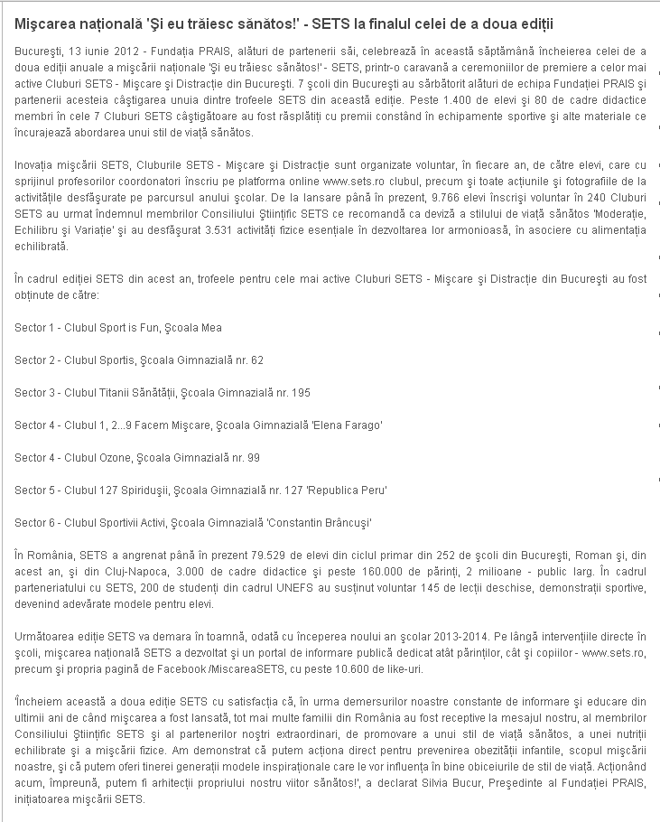

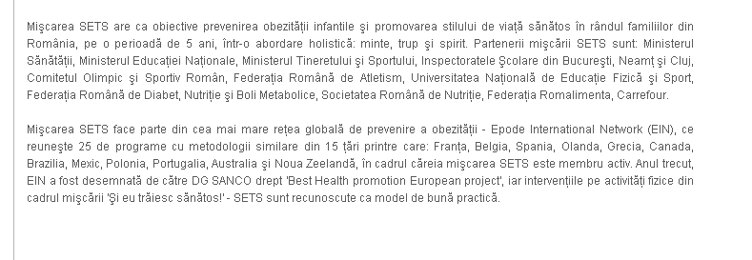

http://www.agerpres.ro/media/index.php/comunicate/item/203150-Comunicat-de-pres-Fundaia-PRAIS.html

