WWW.CLICKTGV.RO
© PRAIS Corporate Communications
© PRAIS Corporate Communications
14.05.2013

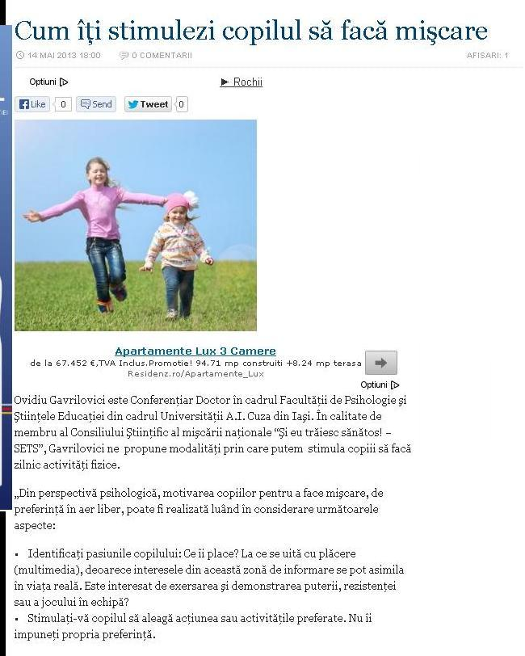

http://clicktgv.ro/cum-iti-stimulezi-copilul-sa-faca-miscare/

WWW.CSID.RO
© PRAIS Corporate Communications
© PRAIS Corporate Communications
14.05.2013

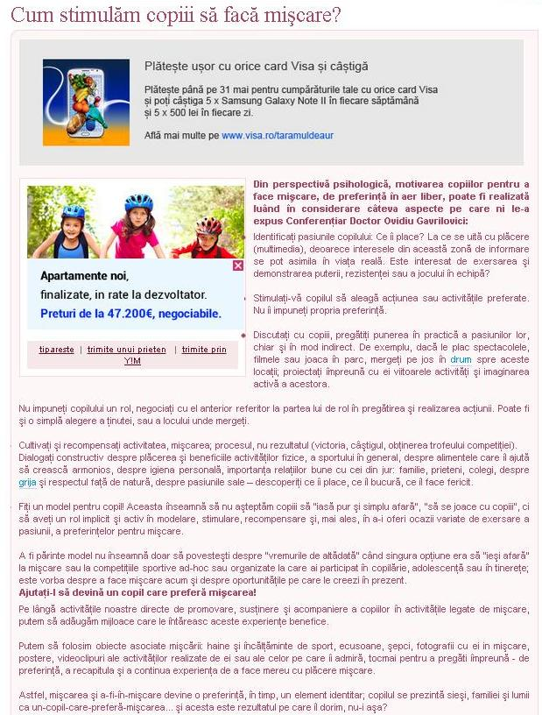

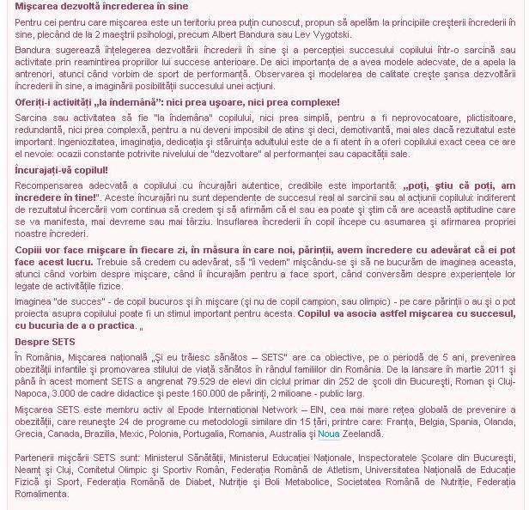

http://www.csid.ro/stiri/noutati/cum-stimulam-copiii-sa-faca-miscare-stire-10876803/
WWW.PROTVMAGAZIN.RO
© PRAIS Corporate Communications
© PRAIS Corporate Communications
14.05.2013

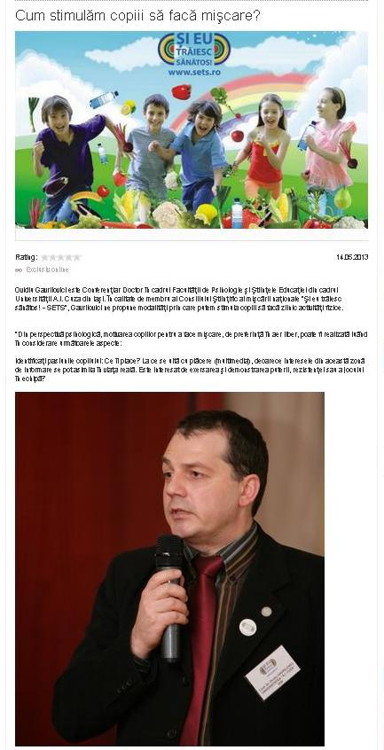

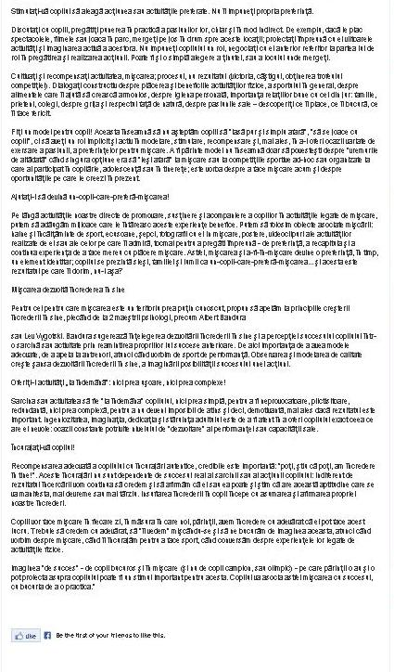

http://www.protvmagazin.ro/stiri/evenimente/a10877285-cum-stimulam-copiii-sa-faca-miscare

WWW.PUNCTULPESTIRI.RO
© PRAIS Corporate Communications
© PRAIS Corporate Communications
14.05.2013

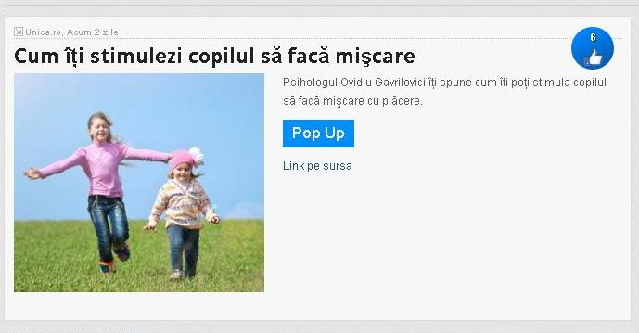

http://www.punctulpestiri.ro/showbiz/cum-iti-stimulezi-copilul-sa-faca-miscare/
WWW.UNICA.RO
© PRAIS Corporate Communications
© PRAIS Corporate Communications
14.05.2013

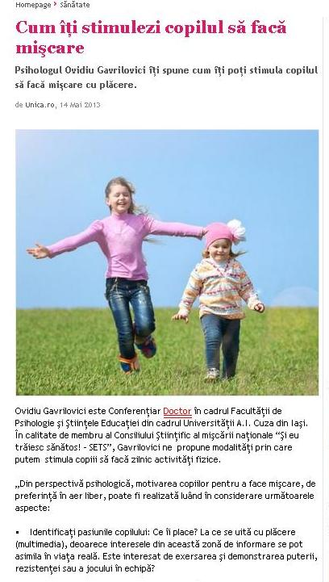

http://www.unica.ro/detalii-articole/articole/cum-stimulezi-copilul-faca-miscare-33125.html
WWW.URBANKID.RO
© PRAIS Corporate Communications
© PRAIS Corporate Communications
14.05.2013

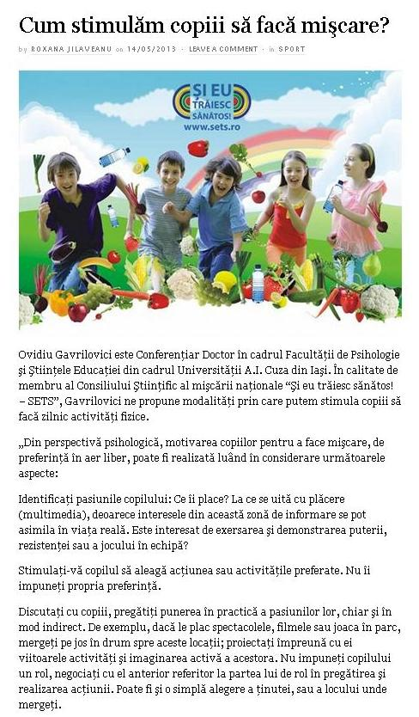

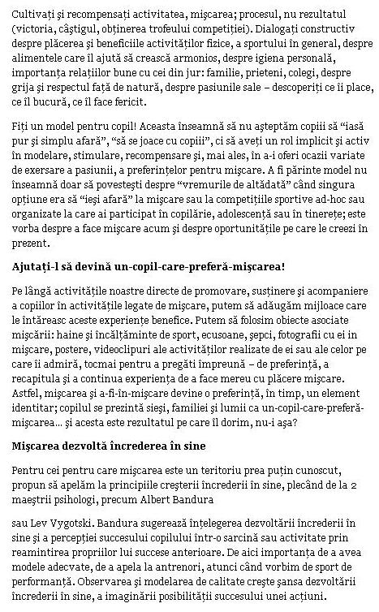

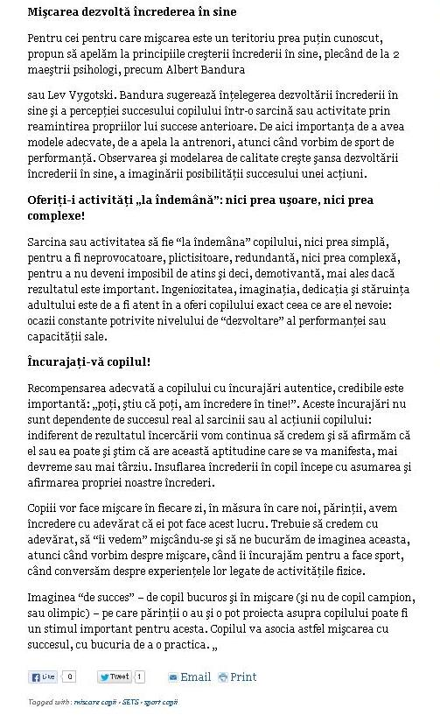

http://comunicate.urbankid.ro/sport/cum-stimulam-copiii-faca-miscare-1661
WWW.121.RO
15.05.2013

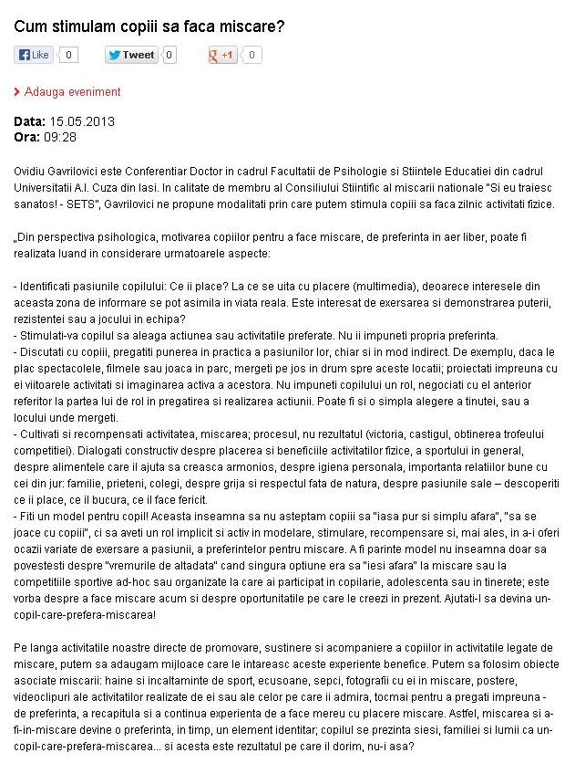

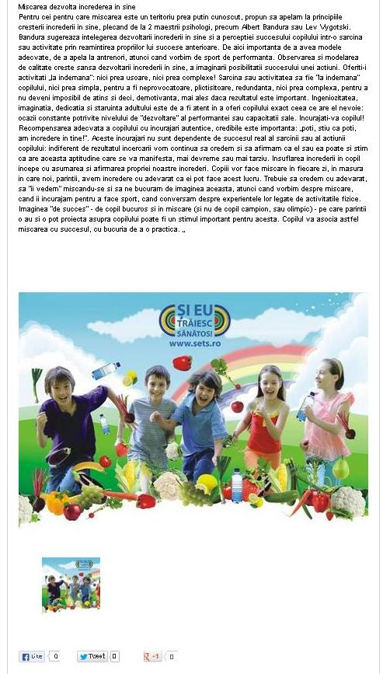

http://www.121.ro/evenimente/ev15903-cum-stimulam-copiii-sa-faca-miscare.html
WWW.BONCAFE.RO
© PRAIS Corporate Communications
© PRAIS Corporate Communications
15.05.2013

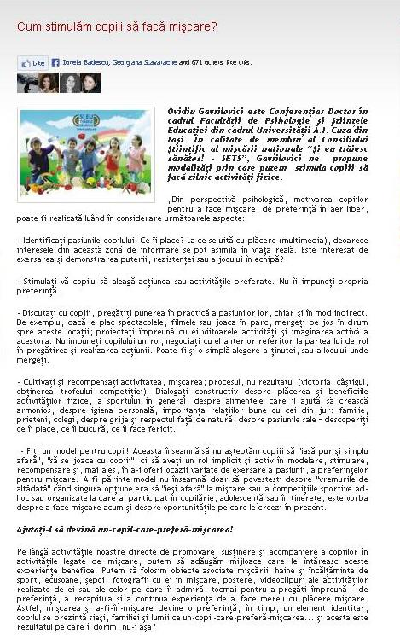

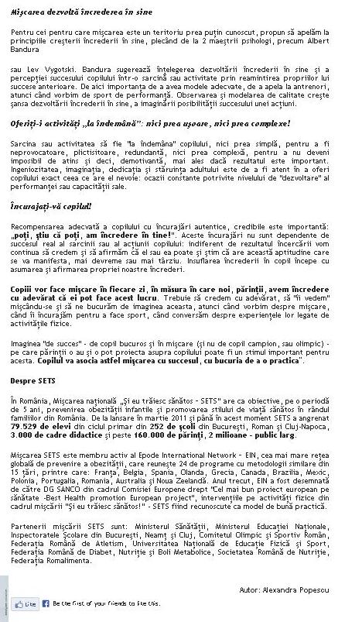

http://boncafe.ro/sante-sans-cafe-cum-stimulam-copiii-sa-faca-miscare-c4_a2945
WWW.FEMINIS.RO
15.05.2013

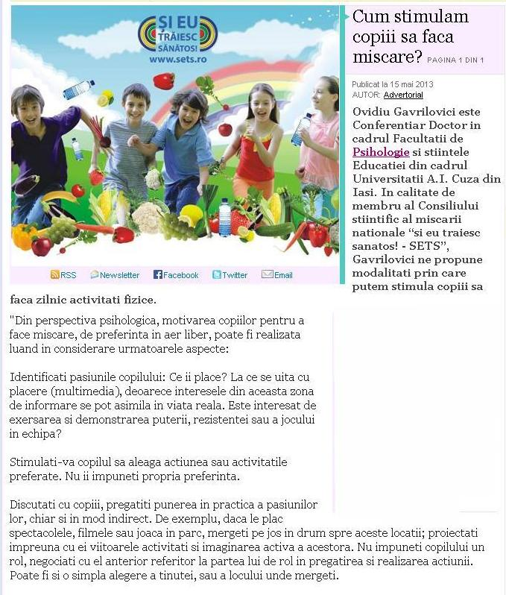

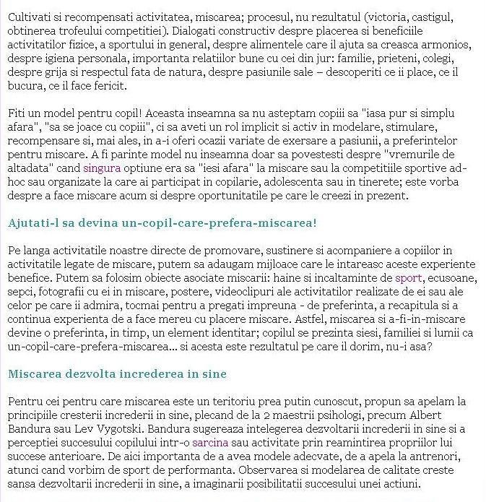

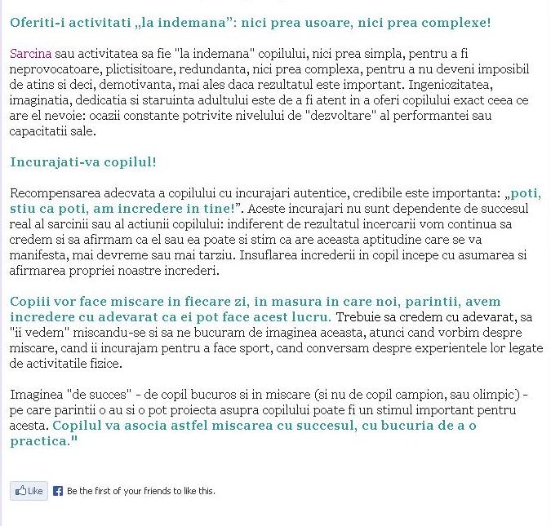

http://www.feminis.ro/dieta-si-sport/cum-stimulam-copiii-sa-faca-miscare-31591
WWW.GHIDULOCATARULUI.RO
15.05.2013

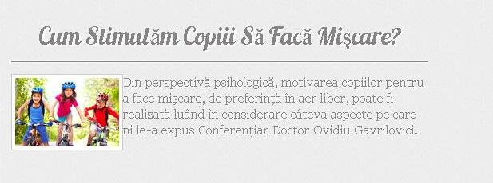

http://ghidulocatarului.ro/cum-stimulam-copiii-sa-faca-miscare/

WWW.HOTNEWS.RO
© PRAIS Corporate Communications
© PRAIS Corporate Communications
15.05.2013

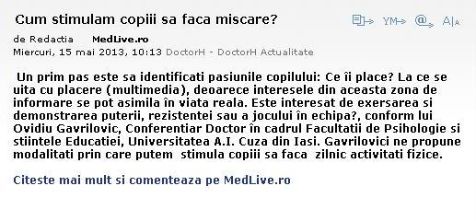

http://www.hotnews.ro/stiri-doctorh_actualitate-14807576-cum-stimulam-copiii-faca-miscare.htm
WWW.MEDLIVE.HOTNEWS.RO
15.05.2013

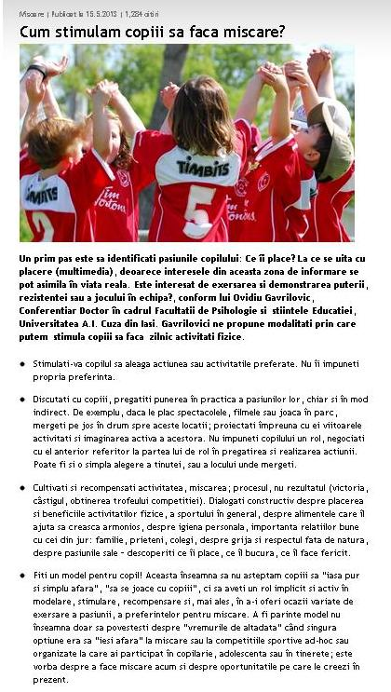

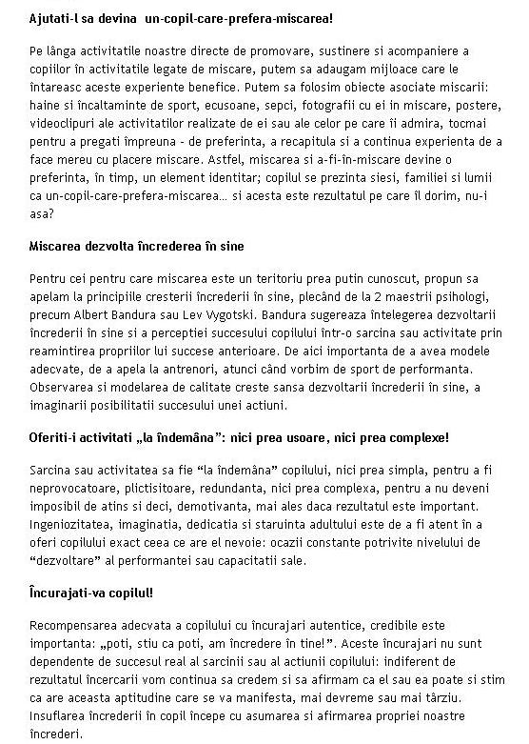

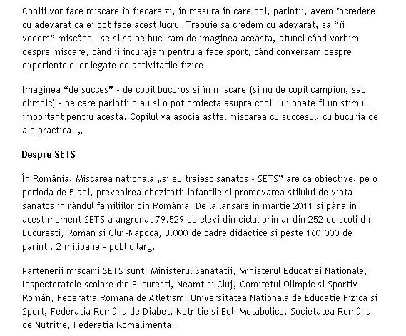

http://medlive.hotnews.ro/cum-stimulam-copiii-sa-faca-miscare.html
WWW.RO.STIRI.YAHOO.COM
15.05.2013

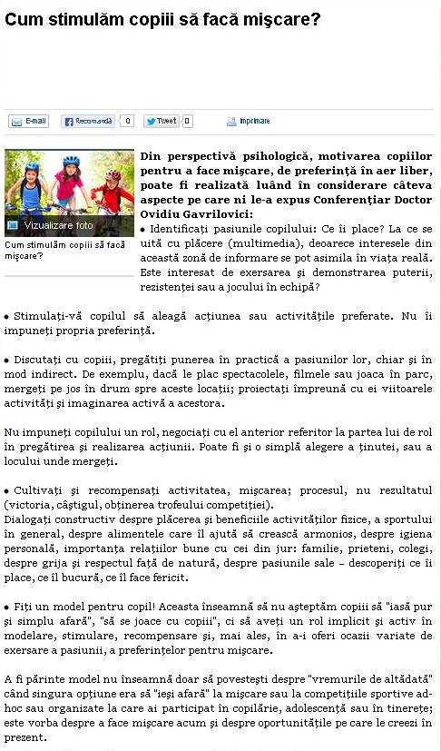

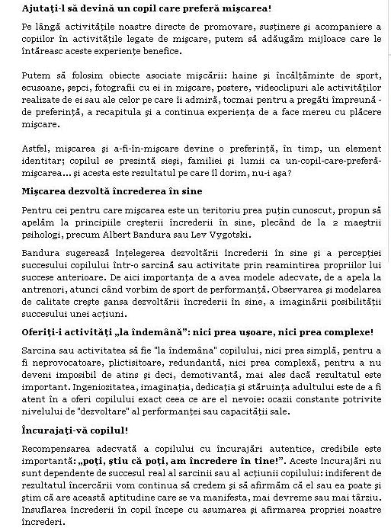

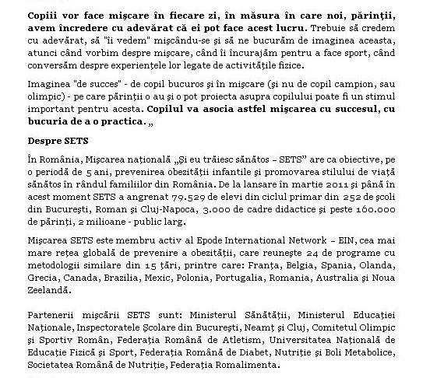

http://ro.stiri.yahoo.com/cum-stimul%C4%83m-copiii-s%C4%83-fac%C4%83-mi%C5%9Fcare-071100134.html
WWW.STIREAZILEI.INFO
15.05.2013

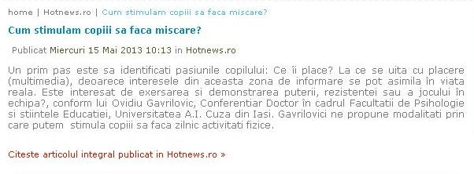

http://www.stireazilei.info/hotnews/cum-stimulam-copiii-sa-faca-miscare/
WWW.STIRITARGOVISTE.RO
15.05.2013

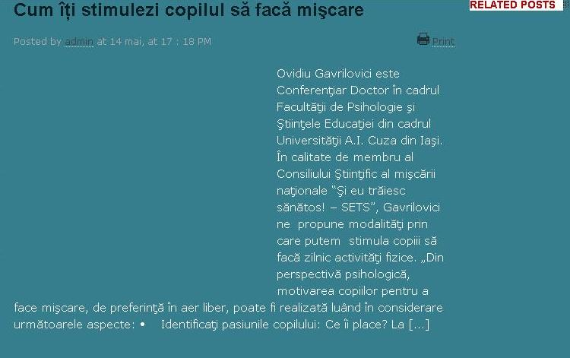

http://www.stiritargoviste.ro/cum-iti-stimulezi-copilul-sa-faca-miscare/
WWW.ZIAREAZ.RO
15.05.2013

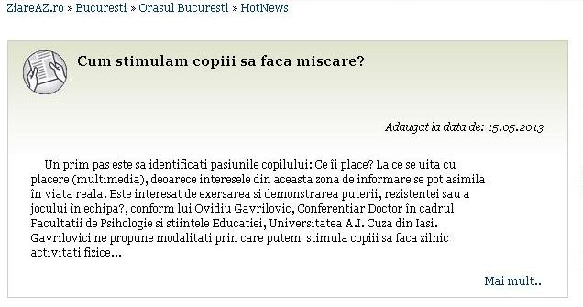

http://www.ziareaz.ro/agentii-de-presa/articole/hotnews/cum-stimulam-copiii-sa-faca-miscare.html
WWW.ZIARELIVE.RO
© PRAIS Corporate Communications
© PRAIS Corporate Communications
15.05.2013

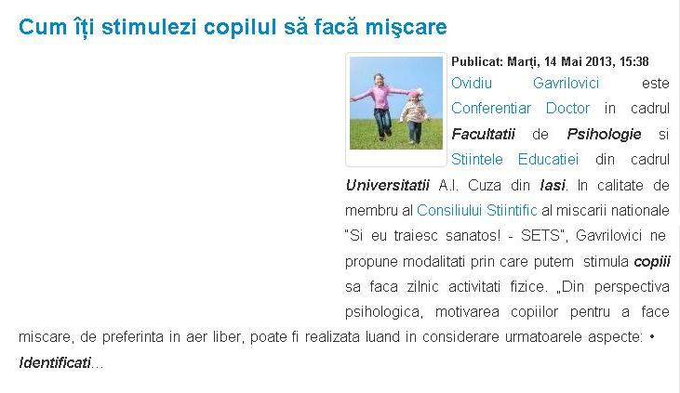

http://www.ziarelive.ro/stiri/cum-iti-stimulezi-copilul-sa-faca-miscare.html
PORTAL-START.COM
16.05.2013

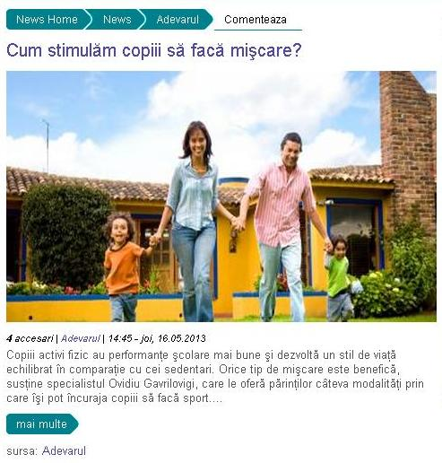

http://news.portal-start.com/post/cumnstimulafm-copiii-saf-facaf-miaycare/
WWW.ADEVARUL.RO
16.05.2013

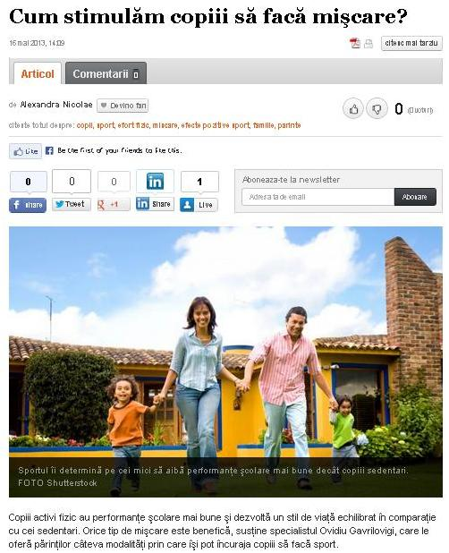

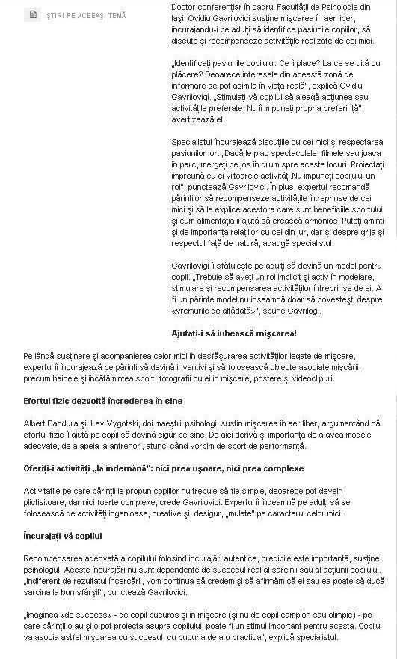

http://adevarul.ro/life-style/parinti/cumstimulam-copiii-faca-miscarec-1_5194b22a053c7dd83fa23061/index.html
WWW.BZI.RO
16.05.2013

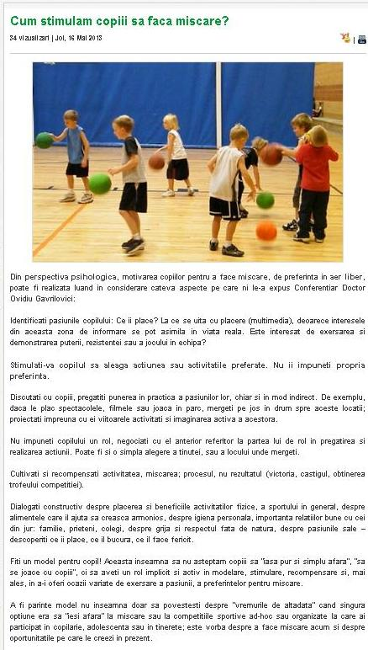

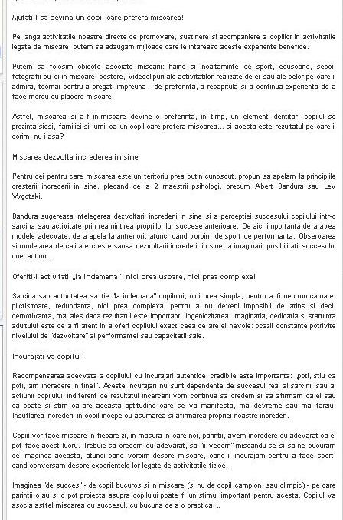

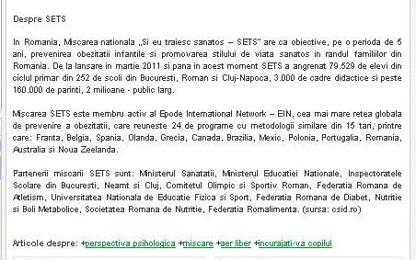

http://sanatate.bzi.ro/cum-stimulam-copiii-sa-faca-miscare-26870
WWW.ORASUL-TULCEA.RO
16.05.2013

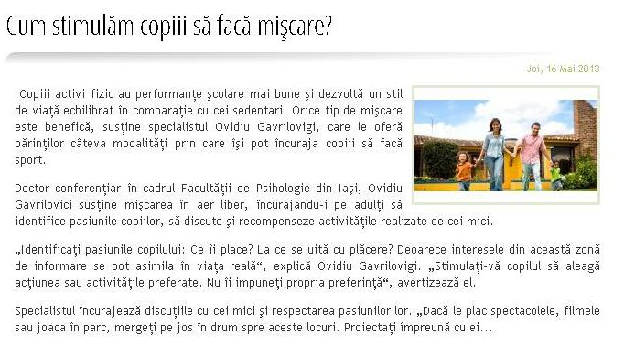

http://www.orasul-tulcea.ro/stiri/cumstimulam-copiii-sa-faca-miscare.html
WWW.SAPTAMANA.COM
16.05.2013

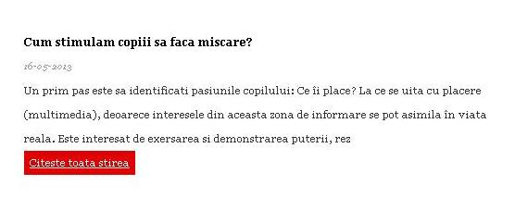

http://www.saptamana.com/5608813/cum+stimulam+copiii+sa+faca+miscare%3F
WWW.ZIAR.COM
16.05.2013

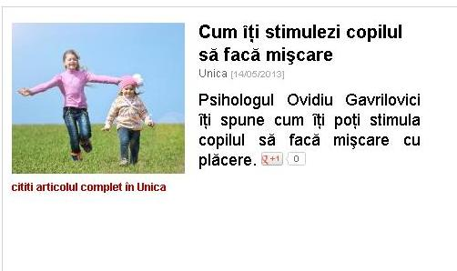

http://www.ziar.com/articol-din-ziar?id_syndic_article=5680582
WWW.E-STIREAZILEI.RO
17.05.2013

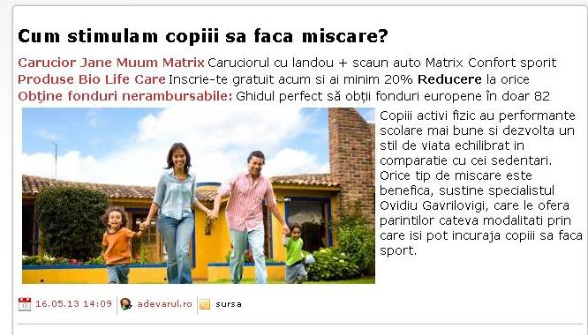

http://www.e-stireazilei.ro/stire.aspx?id=32036102&titlu=Cumstimulam-copiii-sa-faca-miscare&sub=&cat=
WWW.EVA.RO
17.05.2013

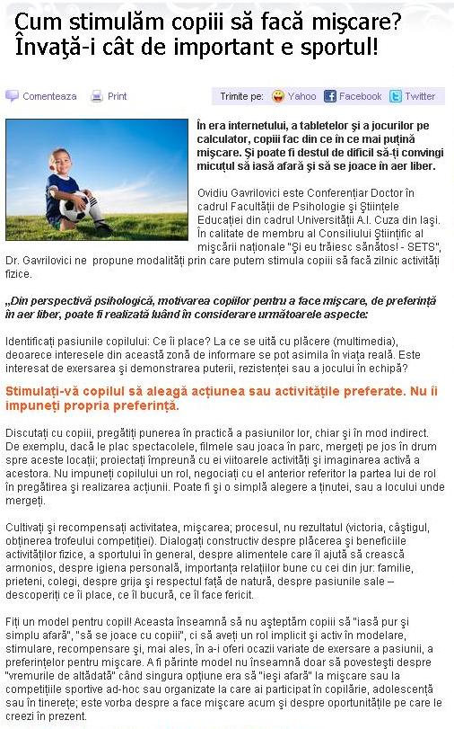

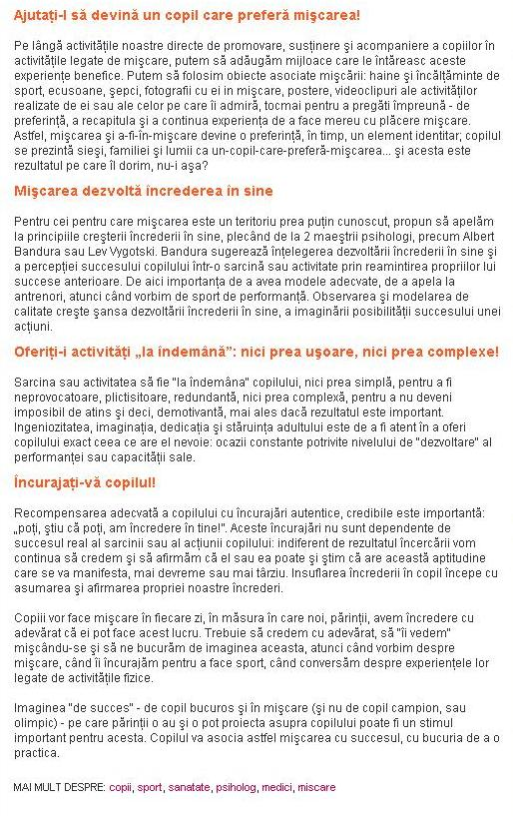
http://www.eva.ro/casa-si-familie/copii/cum-stimulam-copiii-sa-faca-miscare-invata-i-cat-de-important-e-sportul-articol-51395.html
WWW.GARBO.RO
17.05.2013

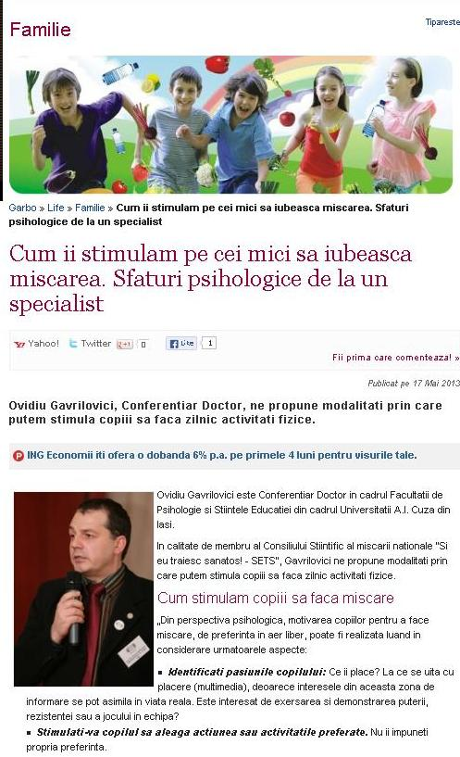

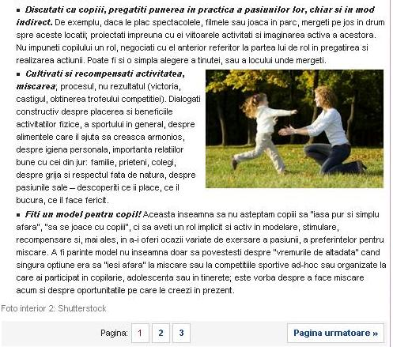

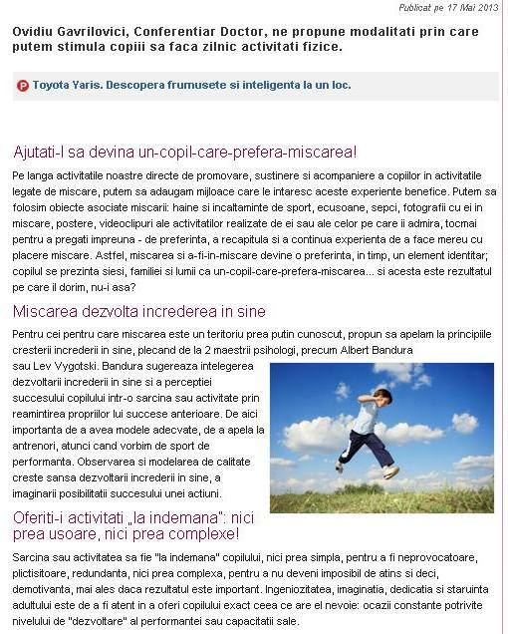

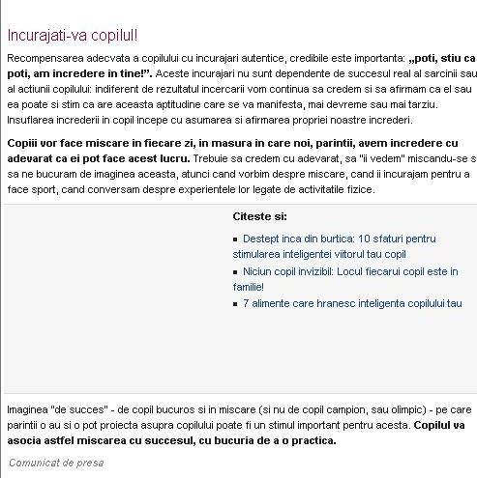

http://www.garbo.ro/articol/Familie/14011/miscare-copii.html
WWW.INDEXSTIRI.RO
17.05.2013

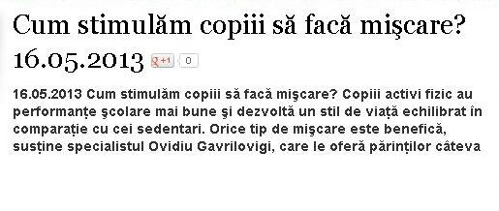

http://www.indexstiri.ro/cumstimulam-copiii-sa-faca-miscare.html
WWW.PESCURT.RO
17.05.2013

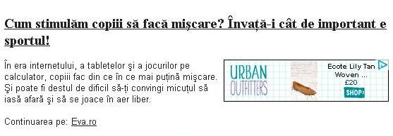

http://pescurt.ro/stiri-internet/cum-stimulam-copiii-sa-faca-miscare-invata-i-cat-de-important-e-sportul_17-05-2013_6423397
WWW.ROMANIAPOZITIVA.RO
17.05.2013

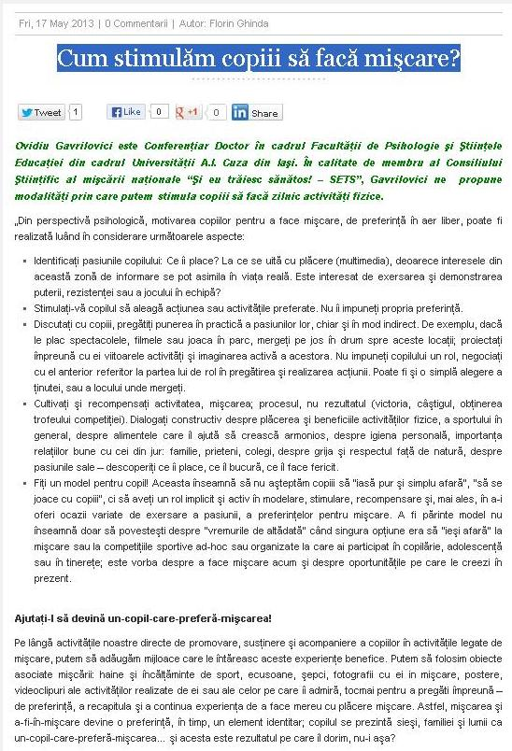

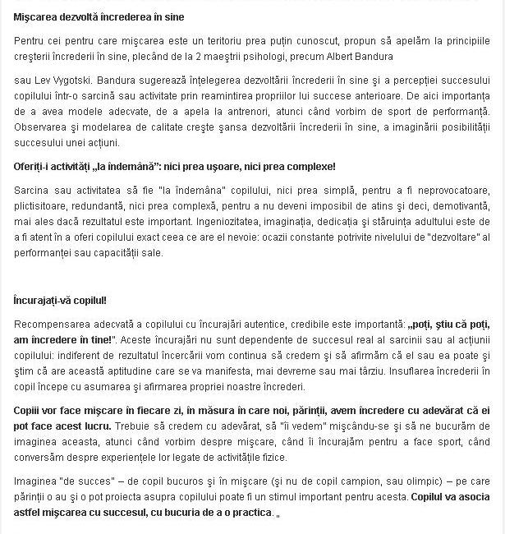



http://www.romaniapozitiva.ro/romania-pozitiva/cum-stimulam-copiii-sa-faca-miscare/
WWW.STIRI-AZI.RO
17.05.2013

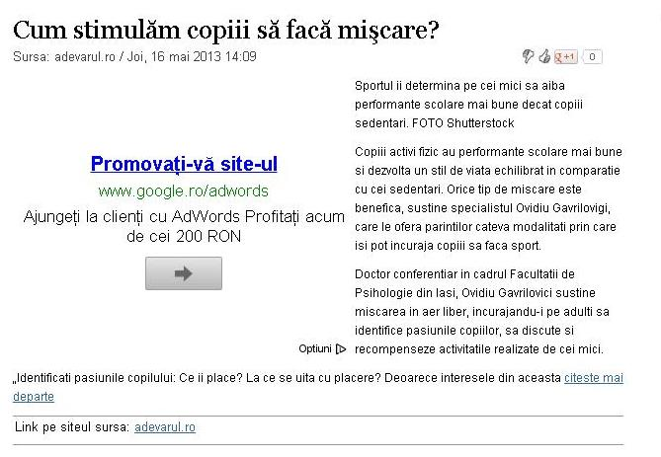

http://www.stiri-azi.ro/ziare/articol/articol/cum-stimulam-copiii-sa-faca-miscare/sumar-articol/129081215/
WWW.ZIAREGRATIS.RO
17.05.2013

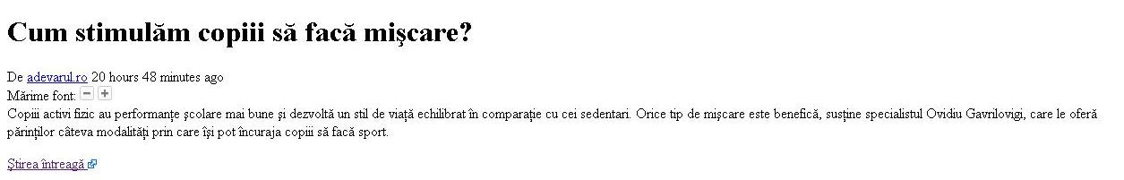

http://ziaregratis.ro/stiri-de-ultima-ora/115116-cum-stimulam-copiii-sa-faca-miscare.html
WWW.TATI.RO
18.05.2013

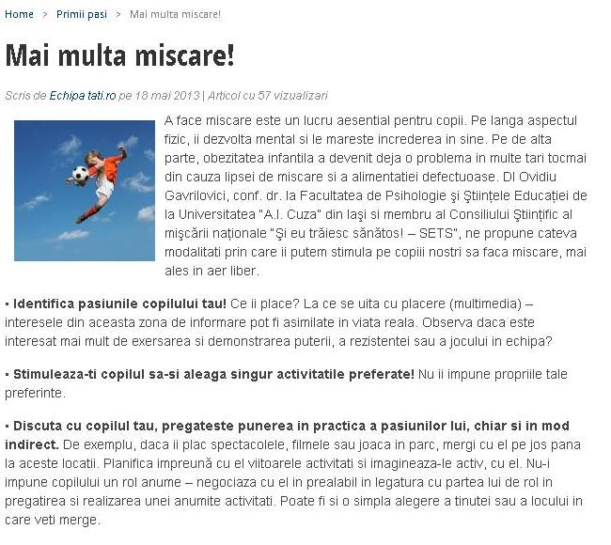

http://tati.ro/mai-multa-miscare.html
WWW.FASHIONANDBEAUTY.RO
20.05.2013

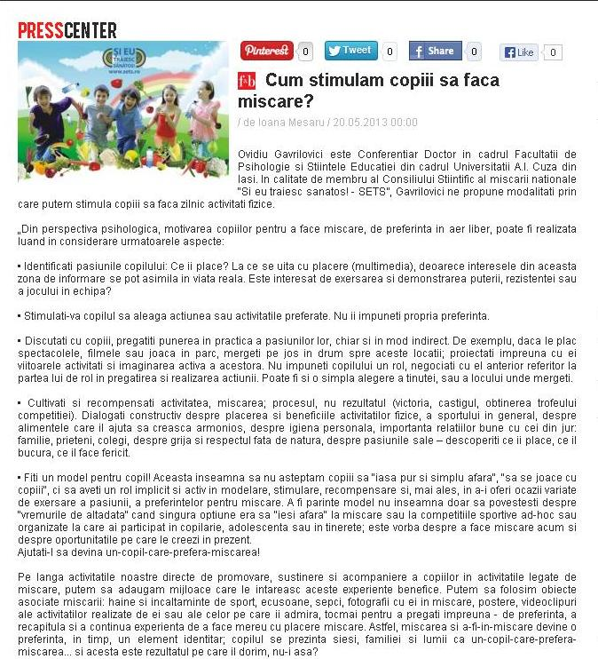

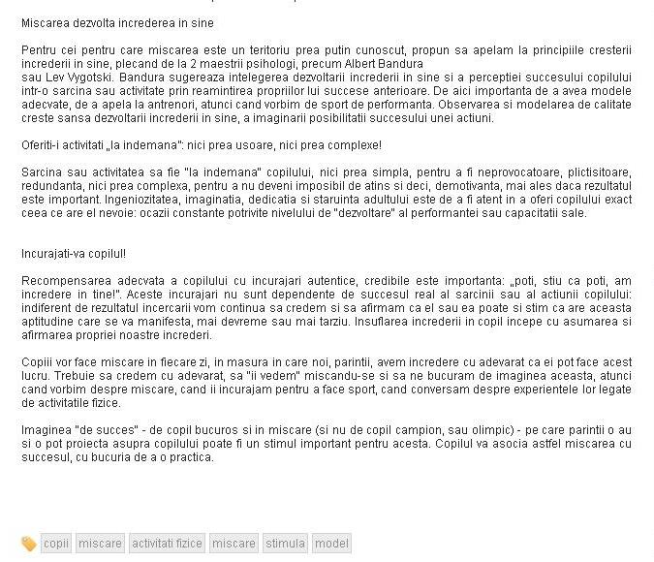

http://fashionandbeauty.ro/presscenter/cum-stimulam-copiii-sa-faca-miscare

