WWW.ELE.RO
© PRAIS Corporate Communications
© PRAIS Corporate Communications
16.09.2013

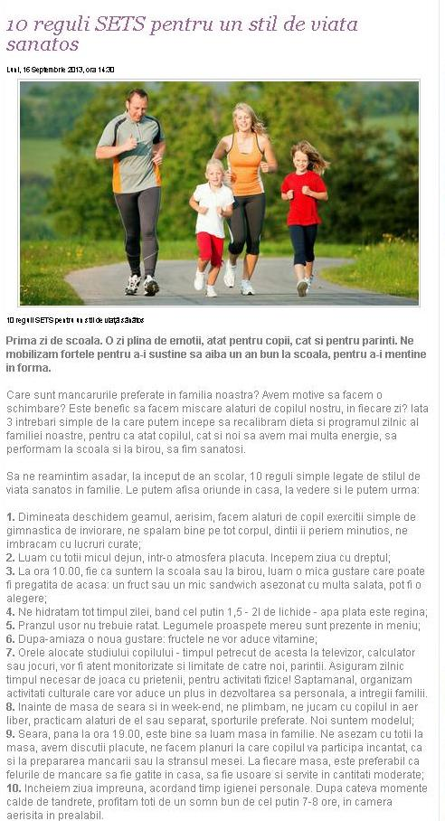

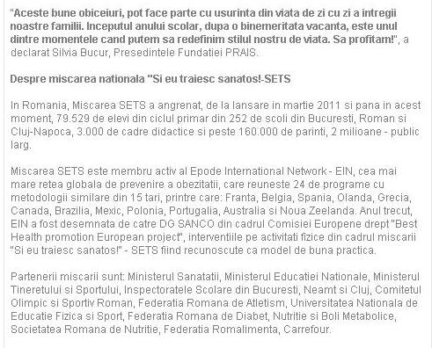

http://www.ele.ro/sanatate/stiri-sanatate/10-reguli-sets-pentru-un-stil-de-viata-sanatos-28184

WWW.E-STIREAZILEI.RO
16.09.2013

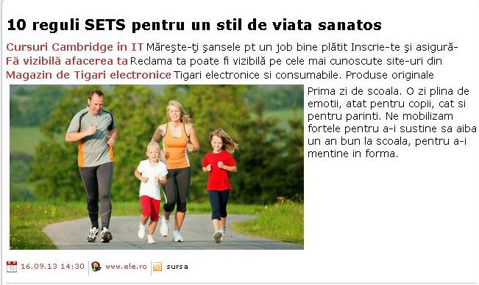

http://www.e-stireazilei.ro/stire.aspx?id=38752326&titlu=10-reguli-SETS-pentru-un-stil-de-viata-sanatos&sub=&cat=

WWW.NEWS-LINE.RO
16.09.2013

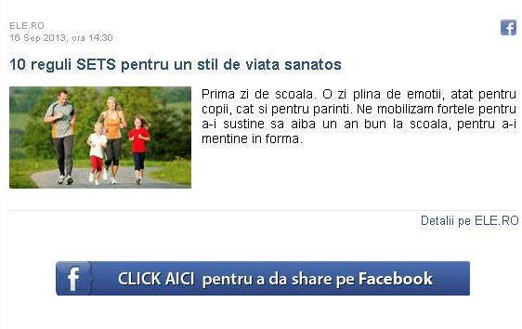

http://news-line.ro/stire.html?id=317441&10-reguli-SETS-pentru-un-stil-de-viata-sanatos

WWW.FEMININ.PUBLICARE.RO
16.09.2013

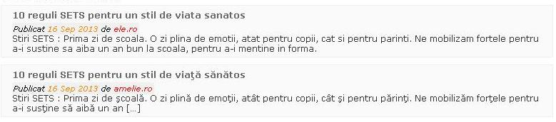

http://feminin.publicare.ro/search.html?q=SETS

WWW.AGERPRES.RO
16.09.2013

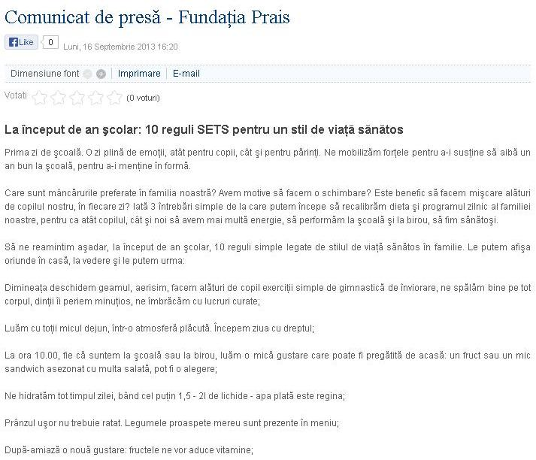

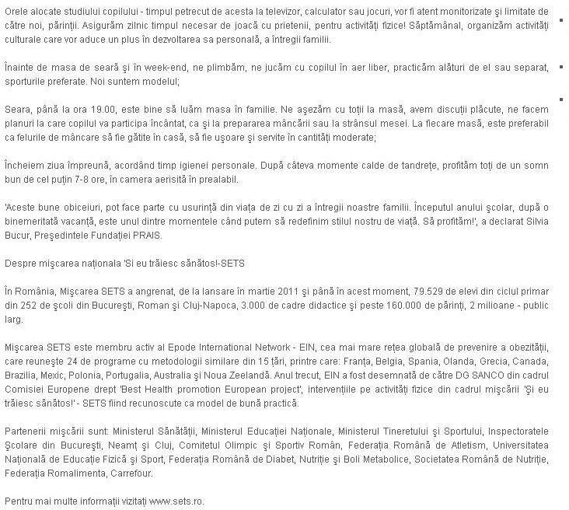

http://www.agerpres.ro/media/index.php/comunicate/item/223061-Comunicat-de-pres-Fundaia-Prais.html

WWW.SUPERBEBE.RO
16.09.2013

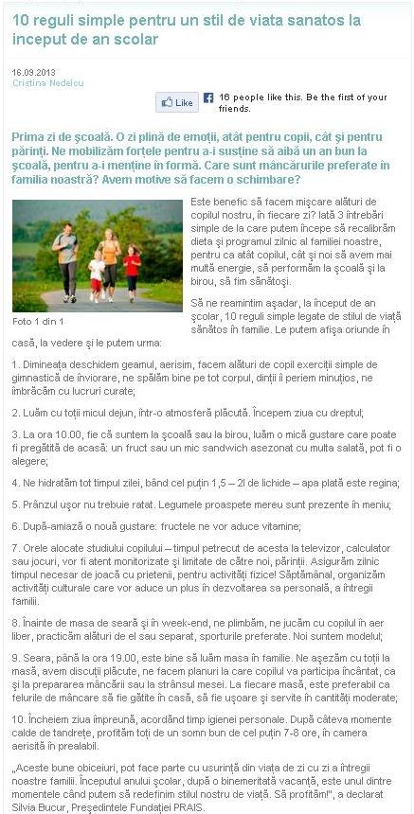

http://www.superbebe.ro/ingrijire/pentru-copil/10_reguli_simple_pentru_un_stil_de_viata_sanatos_la_inceput_de_an_scolar

WWW.RFI.RO
16.09.2013

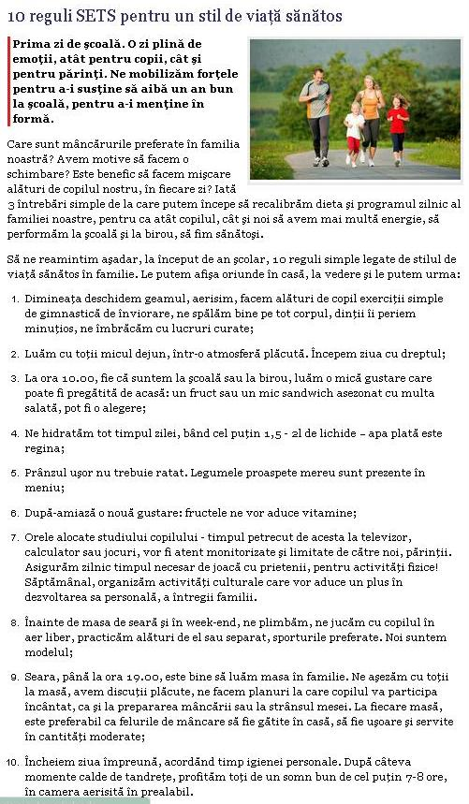

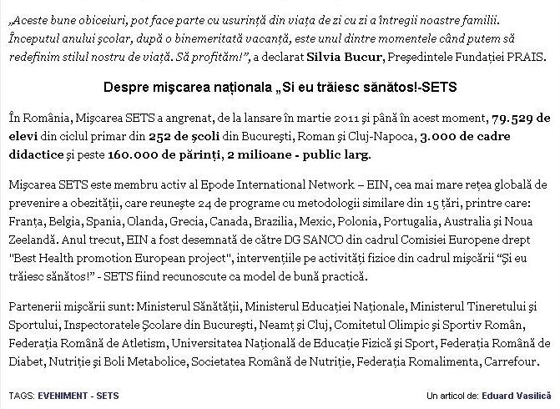

http://www.rfi.ro/articol-stiri-societate-44179-10-reguli-sets-un-stil-viata-sanatos

WWW.NEWS.PORTAL-START.COM
16.09.2013

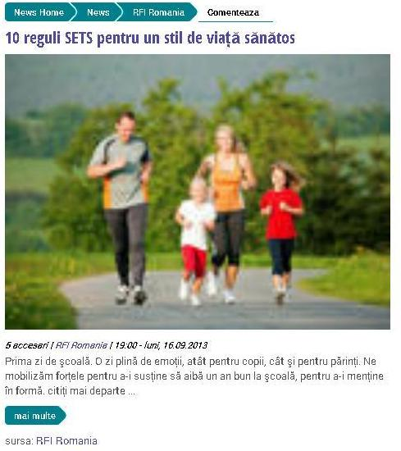

http://news.portal-start.com/post/10-reguli-sets-pentru-un-stil-de-vialla/

WWW.MUJER.RO
16.09.2013

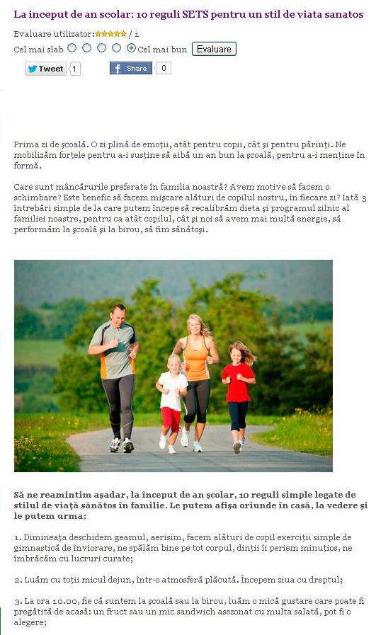

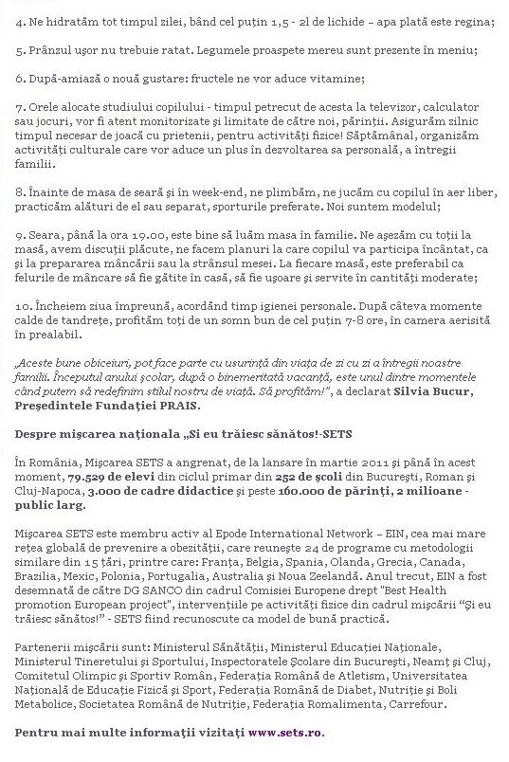

http://www.mujer.ro/la-inceput-de-an-scolar-10-reguli-sets-pentru-un-stil-de-viata-sanatos

WWW.AMELIE.RO
16.09.2013

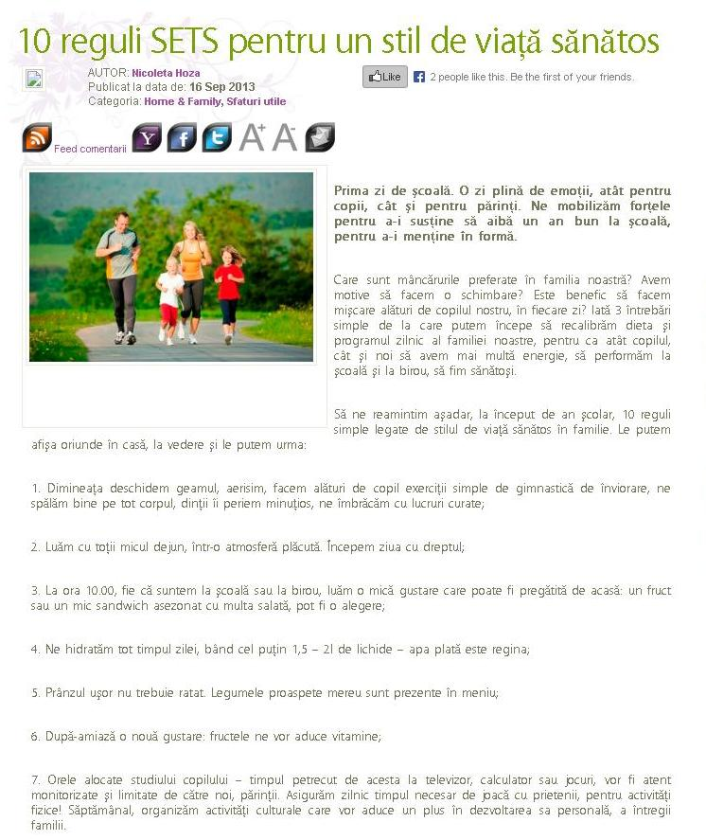

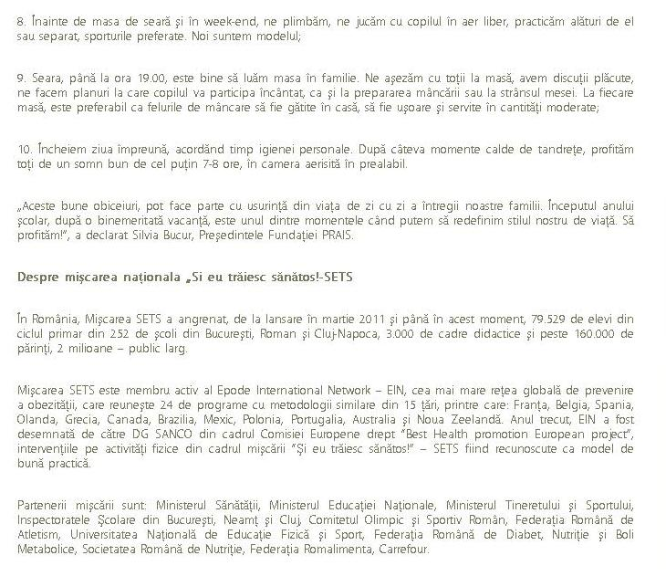

http://amelie.ro/homefamily/10-reguli-sets-pentru-un-stil-de-viata-sanatos
WWW.URBANKID.RO
16.09.2013
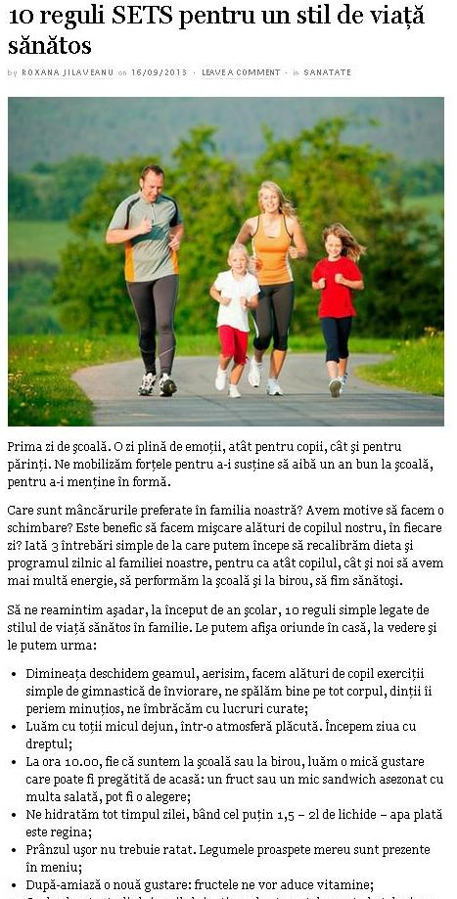

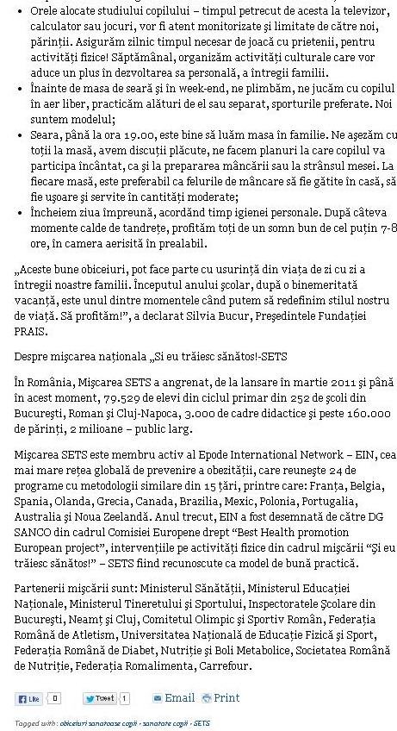

http://comunicate.urbankid.ro/sanatate/10-reguli-sets-stil-viata-sanatos-2219
RFI FACEBOOK
16.09.2013

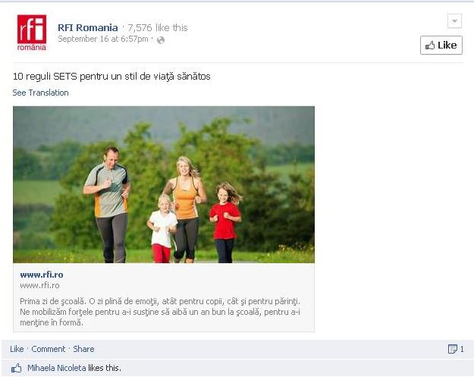

- https://www.facebook.com/RFI.Romania.FM/posts/10151601955786640

WWW.GRABO.RO
16.09.2013
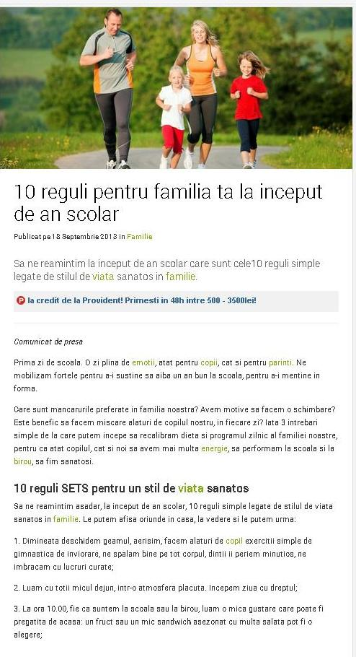

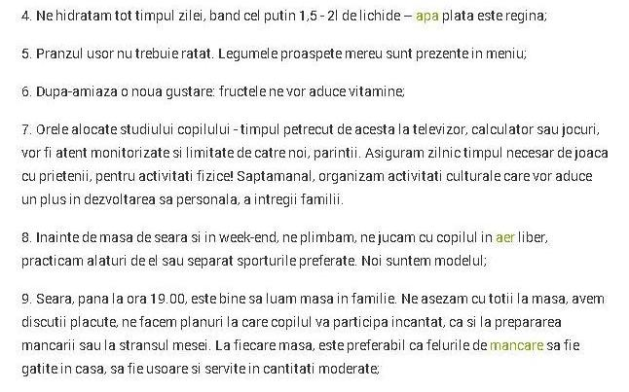
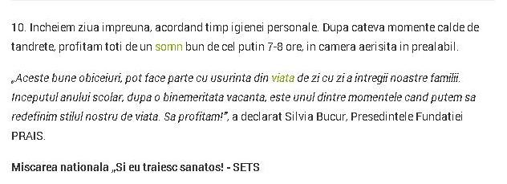
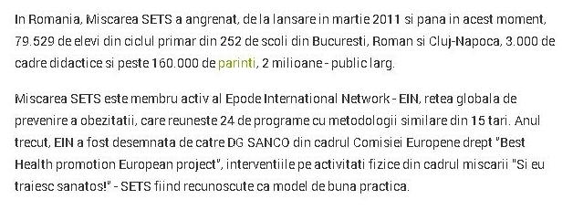

http://www.garbo.ro/articol/Familie/14914/10-reguli-pentru-familia-ta-la-inceput-de-an-scolar.html

WWW.KUDIKA.RO
18.09.2013
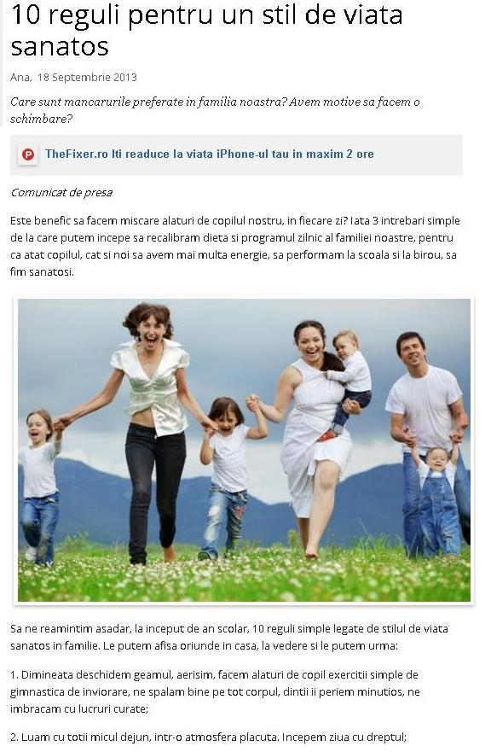

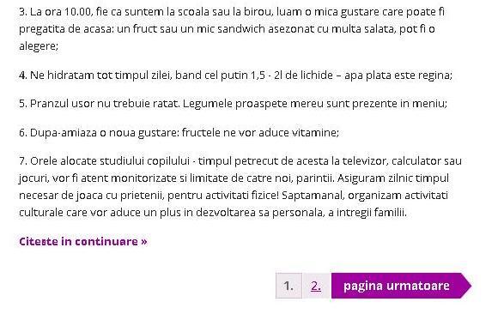
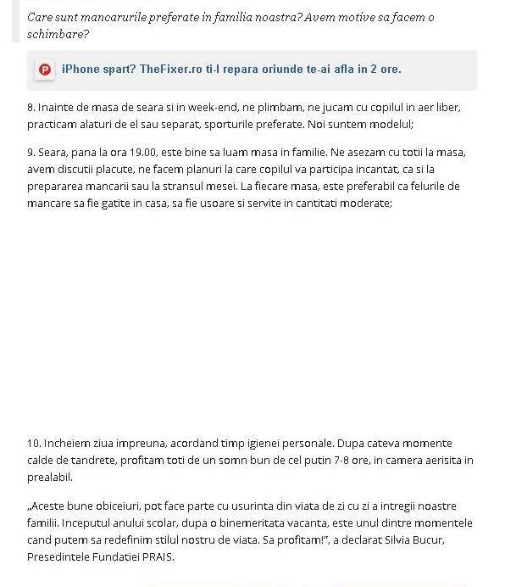

http://healthy.kudika.ro/articol/healthy~preventie/29664/10-reguli-pentru-un-stil-de-viata-sanatos.html

WWW.ROMANIALIBERA.RO
19.09.2013

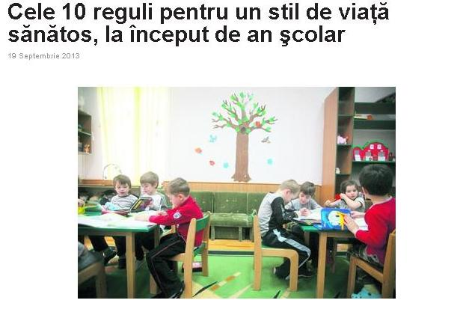

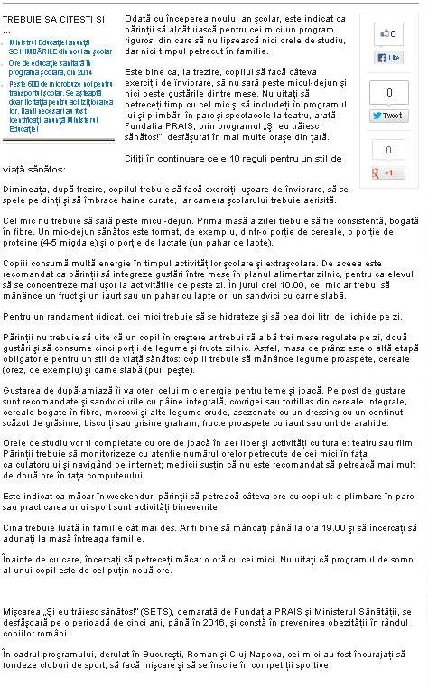

http://www.romanialibera.ro/stil-de-viata/familie/cele-10-reguli-pentru-un-stil-de-viata-sanatos-la-inceput-de-an-scolar-312892.html

WWW.SANATATE.ACASA.RO
19.09.2013

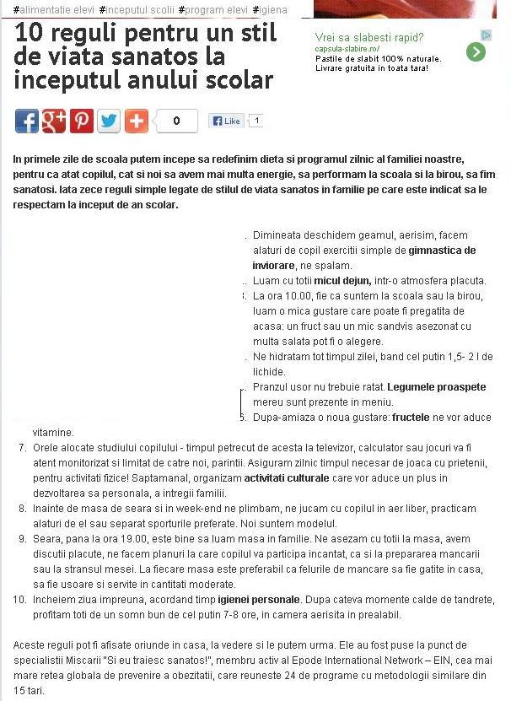
http://sanatate.acasa.ro/boli-7/10-reguli-pentru-un-stil-de-viata-sanatos-la-inceputul-anului-scolar-184658.html
WWW.DECORESQUE.BLOGSPOT.RO
19.09.2013

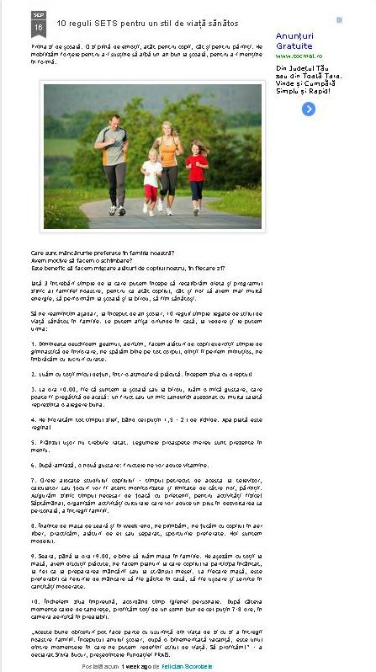

http://decoresque.blogspot.ro/2013/09/10-reguli-sets-pentru-un-stil-de-viata.html
WWW.TATI.RO
19.09.2013
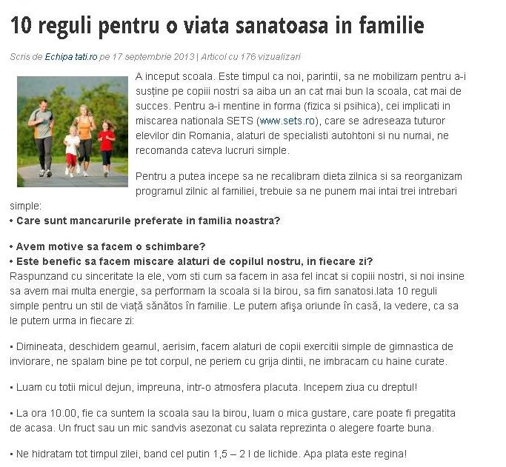
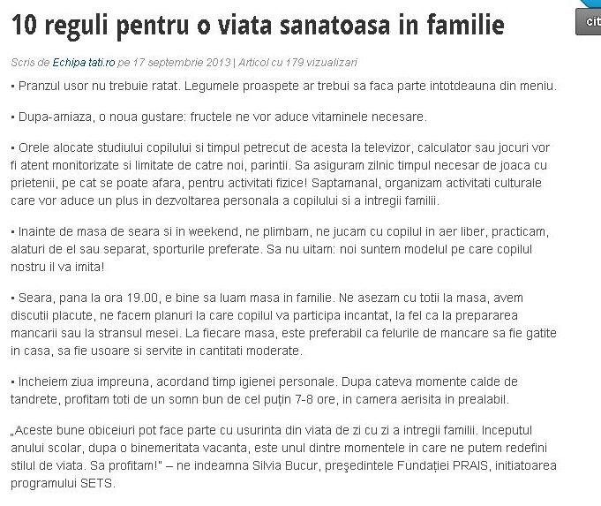

http://tati.ro/10-reguli-pentru-o-viata-sanatoasa-in-familie.html
WWW.121.RO
19.09.2013

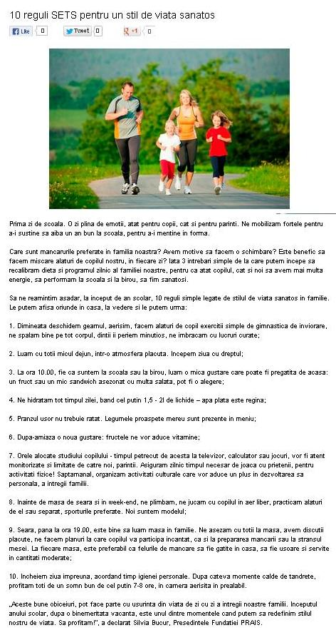
http://www.121.ro/ce_e_nou/stil-de-viata/10-reguli-sets-pentru-un-stil-de-viata-sanatos-.html

WWW.E-ZIAR.RO
19.09.2013

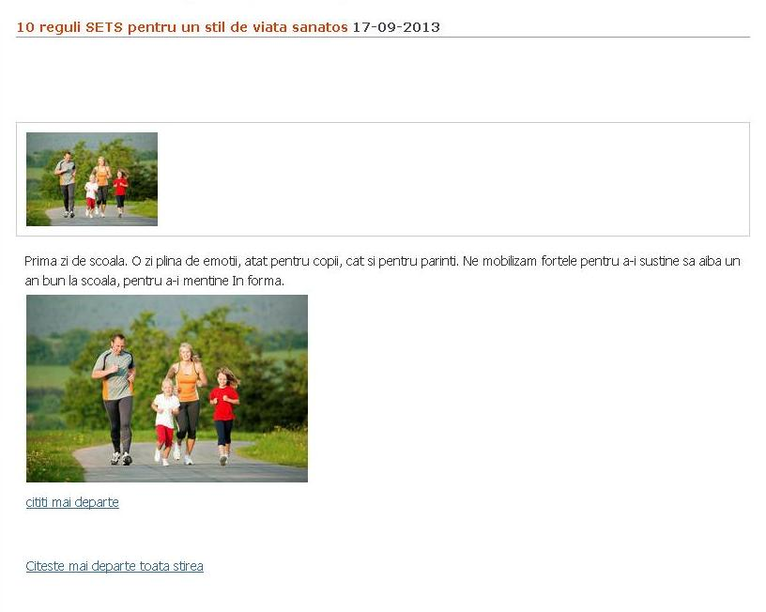

http://www.e-ziar.ro/stire-10_reguli_sets_pentru_un_stil_de_viata_sanatos-793187.html

WWW.SFATULPARINTILOR.RO
19.09.2013

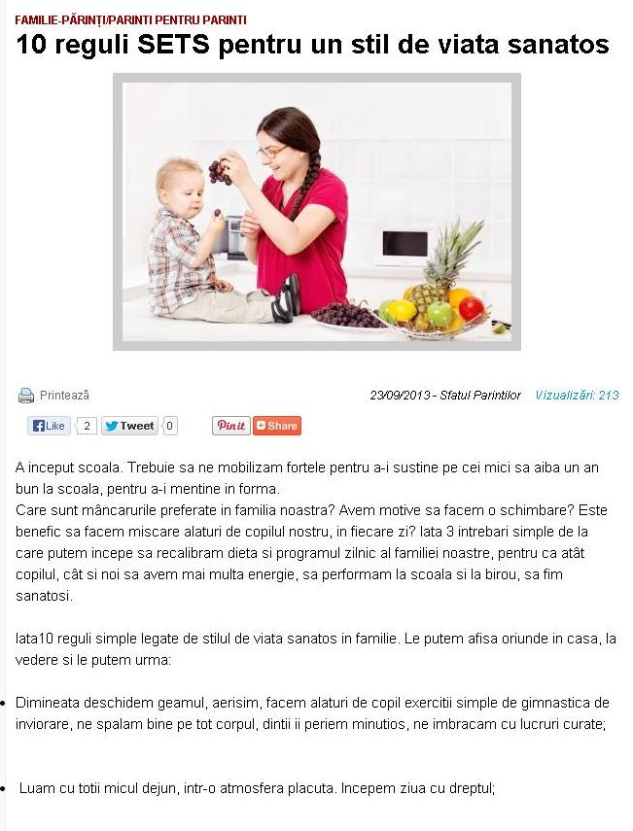

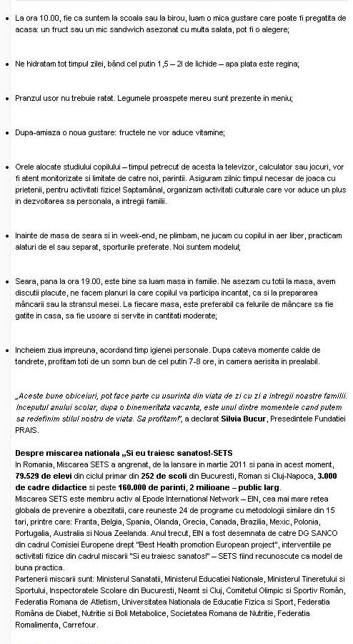

http://sfatulparintilor.ro/newsletter/10-reguli-sets-pentru-un-stil-de-viata-sanatos/

ROMANIA LIBERA
19.09.2013

